AN EXPLAINABLE HIERARCHICAL DEEP LEARNING FRAMEWORK FOR PNEUMONIA DETECTION AND SUBTYPE CLASSIFICATION
A PROJECT REPORT
22CSP72 - PROJECT WORK II Phase I
Submitted by
KAVIN R
23CSR105
KAVIYA R
23CSR106
MANEDEEP M
23CSR120
in partial fulfilment of the requirements
for the award of the degree of
BACHELOR OF ENGINEERING
IN
COMPUTER SCIENCE AND ENGINEERING
DEPARTMENT OF COMPUTER SCIENCE AND ENGINEERING

(Autonomous)
PERUNDURAI ERODE – 638 060
OCTOBER 2026
DEPARTMENT OF COMPUTER SCIENCE AND ENGINEERING
KONGU ENGINEERING COLLEGE
(Autonomous)
PERUNDURAI ERODE – 638 060
OCTOBER 2026
BONAFIDE CERTIFICATE
This is to certify that the project report entitled AN EXPLAINABLE HIERARCHICAL DEEP LEARNING FRAMEWORK FOR PNEUMONIA DETECTION AND SUBTYPE CLASSIFICATION is the bonafide record of project work done by KAVIN R (Register no: 23CSR105), KAVIYA R (Register no: 23CSR106) and MANEDEEP M (Register no: 23CSR120) in partial fulfilment of the requirements for the award of the Degree of Bachelor of Engineering in Computer Science and Engineering of Anna University, Chennai during the year 2026-2027.
SUPERVISOR HEAD OF THE DEPARTMENT
(Signature with seal)
Date:
Submitted for the end semester viva voce examination held on ____________________
INTERNAL EXAMINER EXTERNAL EXAMINER

DEPARTMENT OF COMPUTER SCIENCE AND ENGINEERING
KONGU ENGINEERING COLLEGE
(Autonomous)
PERUNDURAI ERODE – 638 060
OCTOBER 2026
DECLARATION
We affirm that the project report titled AN EXPLAINABLE HIERARCHICAL DEEP LEARNING FRAMEWORK FOR PNEUMONIA DETECTION AND SUBTYPE CLASSIFICATION being submitted in partial fulfilment of the requirements for the award of Bachelor of Engineering is the original work carried out by us. It has not formed the part of any other project report or dissertation on the basis of which a degree or award was conferred on an earlier occasion on this or any other candidate.
Date: KAVIN R
(Reg. No.: 23CSR105)
KAVIYA R
(Reg. No.: 23CSR106)
MANEDEEP M
(Reg. No.: 23CSR120)
I certify that the declaration made by the above candidates is true to the best of my knowledge.

Date: Name and Signature of the Supervisor with seal

ABSTRACT

Pneumonia is one of the main lung infections that needs correct and timely diagnosis, especially in children and elderly people. Currently, X-ray imaging of the chest is used on a very wide scale to make a diagnosis of pneumonia. But, accurate interpretation is challenging due to bacterial, viral and COVID-19 pneumonia have similar radiographic patterns. Moreover, there are many urgent clinical needs for reliable computer-assisted analysis, especially in rural and resource-limited healthcare facilities where there is a lack of experienced radiologists. Besides this, the current system is not easy to understand the type of pneumonia (sub-classification) and is time consuming.

To overcome the above mentioned challenges, the work introduces an explainable two-stage hierarchical deep learning framework. The proposed framework has two stages. The first stage is used to classify chest X-ray images into Normal or Pneumonia, the second stage is to identify the type of Pneumonia as either COVID-19 or Bacterial or Viral. In the two stages, the dual-backbone structure of EfficientNet-B0 and DenseNet-121 is used to extract features. In addition, the multi-head self-attention, feature fusion, residual processing, attention augmentation and dynamic spatial attention pooling are added to enhance feature representation and classification

The proposed framework also includes further information about the pneumonia sub-classification, using Gradient-weighted Class Activation Mapping (Grad-CAM), which will assist the radiologists to locate the infected area. Therefore, the framework will be implemented as a clinical decision support and research tool for the initial assessment of pneumonia and to aid clinicians, especially in sectors where specialist radiological skills are not readily available in the health care system.

ACKNOWLEDGEMENT

We express our sincere thanks and gratitude to Thiru. E. R. K. KRISHNAN., M.com our beloved Correspondent, and all other philanthropic trust members of Kongu Vellalar Institute of Technology Trust who have always encouraged us in academic and co-curricular activities.

We are extremely thankful with no words of a formal nature to the dynamic Principal Dr. R. PARAMESHWARAN, M.E, Ph.D., for providing the necessary facilities to complete our work.

We would like to express our sincere gratitude to our respected Head of the Department Dr. S. MALLIGA, M.E., Ph.D., for providing the necessary facilities.

We extend our thanks to Ms. J. GOWTHAMI, M.E., Assistant Professor, Computer Science and Engineering, Project Coordinator for her encouragement and valuable advice that made us carry out the project work successfully.

We extend our gratitude to our Supervisor Dr. K. DINESH M.E., Ph.D., Associate Professor of Computer Science and Engineering, for his valuable ideas and suggestions, which have been very helpful in the project. We are grateful to all the faculty members of the Computer Science and Engineering Department, for their support.

We sincerely thank the Centre of Excellence in High Performance Computing for Innovative Intelligent Solutions (HPC - IIS) and the Department of Computer Science and Engineering for providing access to GPU computing facilities. These resources played an important role in completing this project successfully. Their support helped us carry out model development and experiments more efficiently and improve the overall performance of our work.

` TABLE OF CONTENTS

CHAPTER No. | TITLE |  |  | PAGE No.
 | ABSTRACT |  |  | iv
 | LIST OF TABLES  LIST OF FIGURES  LIST OF ABBREVIATIONS |  |  | viii  ix  x
1. | INTRODUCTION |  |  | 1
 | 1.1 | ABOUT THE STUDY |  | 1
 | 1.2 | OBJECTIVE |  | 2
 | 1.3 | SCOPE |  | 2
 | 1.4 | DEEP LEARNING MODELS |  | 2
 |  | 1.4.1 | EfficientNet-B0 | 3
 |  | 1.4.2 | DenseNet121 | 4
2. | LITERATURE REVIEW |  |  | 5
 | 2.1 | RELATED WORKS |  | 5
 | 2.2 | RESEARCH GAP IDENTIFIED |  | 6
3. | SYSTEM REQUIREMENTS |  |  | 7
 | 3.1 | HARDWARE SPECIFICATIONS |  | 7
 | 3.2  3.3  3.4 | SOFTWARE SPECIFICATIONS  SOFTWARE DISCRIPTION  DEVELOPMENT ENVIRONMENT |  | 8  8  9
4. | PROPOSED SYSTEM |  |  | 10
 | 4.1 | PROPOSED ARCHITECHTURE |  | 10
 | 4.2  4.3 | DATASET DISCRIPTION  4.2.1 Dataset 1: Detection  4.2.2 Dataset 2: Pneumonia type  4.2.3 Data integrity checks  IMAGE PRE-PROCESSING  4.3.1 Image Resizing  4.3.2 Histogram Equalisation  4.3.3 Scaling and Backbone-Specific Input  4.3.4 Data Augmentation |  | 11  11  12  12  13  13  14  14  14
 | 4.4 | STAGE 1: NORMAL VS PNEUMONIA  4.4.1 Purpose of Stage 1  4.4.2 Stage 1 Model Architecture  4.4.3 Stage 1 training configuration |  | 15  15  16  17
 | 4.5 | STAGE 2: PNEUMONIA CLASSIFICATION  4.5.1 Purpose of Stage 2  4.5.2 Stage 2 Model Architecture  4.5.3 Stage 2 training configuration |  | 19  19  19  20
 | 4.6 | CONDITIONAL EXECUTION  4.6.1 Conditional Execution  4.6.2 Grad-CAM Explainablity |  | 21  21  21
5 | SYSTEM TESTING AND RESULTS |  |  | 23
 | 5.1 | EVAULATION METRICS |  | 23
 | 5.2 | STAGE 1 RESULTS |  | 23
 | 5.3 | STAGE 2 RESULTS |  | 25
 | 5.4 | COMPLETE SYSTEM TESTING |  | 27
 | 5.5 | DISCUSSION |  | 28
6. | CONCLUSION AND FUTURE ENHANCEMENT |  |  | 29
 | APPENDIX 1 |  |  | 30
 | APPENDIX 2 |  |  | 33
 | REFERENCES |  |  | 35
 | MAPPING TO SDG GOALS |  |  | 36

LIST OF TABLES

TABLE No. | TITLE | PAGE No.
3.1 | Hardware Specifications | 7
3.2 | Software Specifications | 8
4.1 | Dataset 1 Statistics | 12
4.2 | Dataset 2 Statistics | 12
4.3 | Augmentation Settings Used for Training Images | 15
4.4 | Stage 1 Training Hyper-parameters | 18
5.1 | Stage 1 Test Results | 24
5.2 | Stage 1 Results with Calibrated Threshold | 25
5.3 | Stage 2 Test Results | 26
5.4 | Stage 2 Confusion Matrix | 26
5.5 | Functional Tests | 28

LIST OF FIGURES
Figure No | TITLE | Page no
1.1 | EfficientNetB0 Architecture | 3
1.2 | DenseNet-121 Architecture | 4
4.1 | Proposed Hierarchical Architecture | 10
4.2  4.3  5.1  5.2  5.3  5.4 | Stage 1 Model Architecture  Stage 2 Model Architecture  Stage 1 Metric Comparison  Calibrated Stage 1 Results  Per-Class Performance of Stage 2  Confusion Matrix Heatmap for Stage 2 | 17  20  24  25  26  27

LIST OF ABBREVIATIONS
Adam | - | Adaptive Moment Estimation
BCE | - | Binary Cross-Entropy
CNN | - | Convolutional Neural Network
COVID-19 | - | Coronavirus Disease 2019
DenseNet | - | Densely Connected Convolutional Network
EfficientNet | - | Efficient Convolutional Neural Network Architecture
GPU | - | Graphics Processing Unit
Keras | - | High-Level Deep Learning API
OpenCV | - | Open Source Computer Vision Library
ReLU | - | Rectified Linear Unit
TensorFlow | - | Open-Source Machine Learning Framework
X-ray | - | X-Radiation

CHAPTER 1

INTRODUCTION

  - ABOUT THE STUDY

Pneumonia is a serious respiratory condition that affects the lungs and can be identified through abnormalities visible in chest X-ray images. Chest X-rays are commonly used as an important imaging method for examining lung conditions. Nowadays, X-rays are manually verified by the doctors and sometimes it is difficult to identify the pneumonia as bacterial or viral and also it is time consuming. Therefore, doctors find very difficult to classify the exact pneumonia type. Due to the advancement of technology, ML and DL techniques such as Convolutional Neural Networks (CNNs) are widely used for image classification because it can automatically extract important features such as edges, textures, shapes and spatial patterns using filters[8].

Thus, the proposed work develops a hierarchical deep learning framework for pneumonia detection and pneumonia-type classification. The proposed work identifies the exact category of pneumonia in two stages. In stage 1, the chest X-ray is classified as either Normal or Pneumonia. After identifying a pneumonia image, it is passed to Stage 2, which classifies the pneumonia type as COVID-19, Bacterial Pneumonia or Viral Pneumonia.

The proposed work uses two pretrained CNN architectures in each stage, such as EfficientNet-B0 and DenseNet-121 along with attention mechanisms and feature fusion techniques for pneumonia classification. After classification, Grad-CAM is used for highlighting the affected region on which the model focuses in classification of the pneumonia type.

  - OBJECTIVE

The main objectives of the proposed work are as follows:

• To develop a hierarchical deep learning framework for automated pneumonia detection and pneumonia-type classification from chest X-ray images.
• To classify chest X-ray images as Normal or Pneumonia in the first stage and Bacterial Pneumonia, Viral Pneumonia or COVID-19 in the second stage.
• To achieve accurate and timely detection of pneumonia using chest X-ray images.
• To support preliminary pneumonia assessment using computer-assisted analysis, particularly in rural and resource-constrained healthcare sectors.

  - SCOPE

The proposed work focuses on developing a deep-learning-based framework for pneumonia detection and pneumonia-type classification using chest X-ray images. It utilizes preprocessing, EfficientNet-B0 and DenseNet-121, attention mechanisms, feature fusion and two-stage classification, while also incorporating dataset validation and duplicate detection. The proposed work provides a structured approach for automated chest X-ray analysis and pneumonia classification.

  - DEEP LEARNING MODELS

The proposed system uses two pre-trained Convolutional Neural Network (CNN) architectures such as EfficientNet-B0 and DenseNet-121, to extract meaningful features from chest X-ray images for pneumonia classification. Although both models learn visual patterns, the models use different approaches to process image information [8]. EfficientNet-B0 focuses on computational efficiency, whereas DenseNet-121 enables effective feature reuse through dense connections. Together, the models provide complementary feature representations for the proposed classification framework.

    - EfficientNet-B0

EfficientNet-B0 is a lightweight CNN architecture designed to balance computational efficiency with classification performance [8]. To achieve this balance, the network processes chest X-ray images through convolutional and MBConv blocks that progressively identify visual characteristics such as edges and textures. As the image passes through successive blocks, meaningful features are extracted for further processing. Finally, the extracted features form a compact representation that serves as an input to the subsequent pneumonia classification stage.

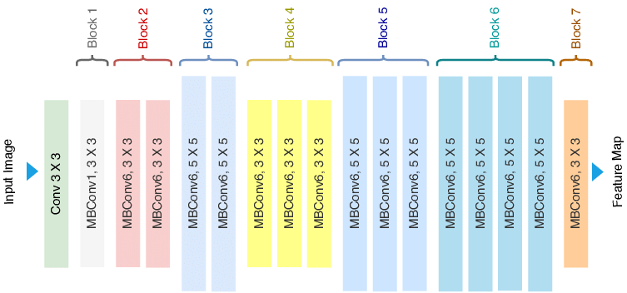
Figure 1.1 EfficientNetB0 – Architecture

Figure 1.1 illustrates the processing flow of EfficientNet-B0 beginning with the chest X-ray image as input. Initially, the stem convolution layer extracts basic visual patterns which are subsequently refined by successive MBConv blocks. Following feature extraction, global average pooling summarizes the learned feature maps into a compact feature vector. Consequently, the resulting representation provides relevant image information for pneumonia classification.

    - DenseNet-121

DenseNet-121 is a CNN architecture that promotes effective feature learning through dense connections between layers. Unlike conventional networks that primarily transfer information between consecutive layers, DenseNet-121 enables later layers to reuse previously learned features[1]. Consequently, important visual information is preserved throughout the network while feature propagation is improved. DenseNet-121 extracts complementary image characteristics that strengthen the feature representation obtained from EfficientNet-B0.

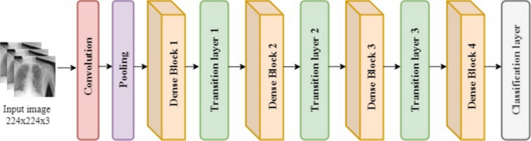
Figure 1.2 DenseNet-121 Architecture

Figure 1.2 illustrates the processing stages of DenseNet-121 starting with an initial convolution and pooling operation to extract basic image features. Subsequently, the extracted information passes through dense blocks where connections enable feature reuse across layers. Finally, global average pooling converts the learned feature maps into a compact feature vector for the subsequent pneumonia classification stage.

CHAPTER 2

LITERATURE REVIEW

2.1 RELATED WORKS

Automated pneumonia detection from chest radiographs has gained much attention with the availability of publicly available datasets and advances in deep learning. An et al. (2024) proposed an attention-based ensemble model that combines EfficientNet-B0 features and DenseNet-121 features and introduces multi-head self-attention, channel-attention fusion and dynamic attention pooling [2]. The model achieved the best test accuracy of 95.19% on the Kermany dataset and hyperparameters were optimized using Optuna [1]. The architecture showed good detection performance but the study was done with only binary classification and was not able to distinguish bacterial pneumonia from viral pneumonia.

In addition, researchers suggested that Transfer learning has also been instrumental in the improvement of the pneumonia classification system, based on X-ray images of the chest. Kermany et al. (2018) presented a dataset with 5,856 paediatric chest X-rays that were annotated for each as normal, bacterial pneumonia or viral pneumonia, which is a commonly used standard for designing automatic diagnostic systems [5]. The study's ability to identify pneumonia from radiographs using features learned from ImageNet was shown to be effective. However, the application of a single detection stage does not independently address the need for a hierarchical diagnosis process.

A number of studies have investigated alternative methods to enhance the accuracy and reliability of the automated detection of lung disease. Goyal and Singh (2023) used Support Vector Machine (SVM), Artificial Neural Network (ANN), K-Nearest Neighbours (KNN) and ensemble classifiers to classify COVID-19 and other pneumonia related lung diseases using handcrafted and deep features [4]. While several feature representations and classification methods were used, a small number of COVID-19 samples and the adoption of distinct datasets hindered the creation of a single detection and pneumonia-type classification pipeline. Likewise, Szepesi and Szilágyi (2022) proposed an optimized Convolutional Neural Network (CNN), which also included dropout in convolutional layers to prevent overfitting without using transfer learning [6]. Although this method is beneficial, this study adopted a single-source paediatric dataset, and only aimed to detect binary pneumonia.

Relationships across various regions in the image have been extended by the use of transformer-based architectures, which have led to the automated detection of pneumonia. Singh et al. (2024) used a Vision Transformer to analyse chest X-ray images and achieved an accuracy of 97.61% with a 95% sensitivity and 98% specificity. The self-attention mechanism is used to extract global image context for the architecture to identify the relevant disease pattern [7]. However, the study was not on pneumonia classification but pneumonia detection and the computational power needed by transformer models can also pose problems for small datasets.

2.2 RESEARCH GAP IDENTIFIED

• Lack of hierarchical diagnosis: Existing studies generally detect or classify in a single step. The proposed work separates the process into two stages, detection followed by type classification.

• Limited feature integration: Earlier studies often use features from a single network. The proposed approach uses dual-backbone feature fusion to improve the feature representation.

• Insufficient attention and explanation: CNN models may treat all image regions alike and rarely explain their output. The proposed work uses channel and spatial attention and presents Grad-CAM evidence with every subtype prediction.

CHAPTER 3

SYSTEM REQUIREMENTS

3.1 HARDWARE SPECIFICATIONS

Hardware requirements specify the physical computing resources and hardware infrastructure needed for training deep learning models, executing the image preprocessing pipeline, hosting backend microservices, generating Explainable AI (Grad-CAM) visualizations and serving the interactive web application.

Component | Minimum Specification | Recommended Specification
Processor (CPU) | Intel Core i5 / AMD Ryzen 5 | Intel Core i7 / AMD Ryzen 7 or higher
RAM | 8 GB DDR4 | 16 GB DDR4 or higher
GPU | Integrated GPU / 4 GB VRAM | NVIDIA T4 / RTX 3080 (8+ GB VRAM) via Google Colab
Storage | 25 GB free disk space (HDD) | 100 GB NVMe SSD (for fast I/O during CXR dataset batch streaming )
Internet Connection | 10 Mbps broadband | 50 Mbps or higher for Drive sync and model upload
Display | 1280 × 720 resolution | 1920 × 1080 Full HD
Table 3.1 Hardware Specifications

Table 3.1 shows the minimum and recommended hardware specifications required for developing and executing the proposed pneumonia detection and classification system. It includes the processor, RAM, GPU, storage capacity, internet connection, and display resolution.

3.2 SOFTWARE SPECIFICAIONS

Software requirements define the programming languages, deep learning frameworks, web technologies, operating systems and supporting libraries necessary to implement, execute and deploy the end-to-end pneumonia detection system. The core deep learning and explainability pipeline is developed using Python, TensorFlow, Keras and OpenCV that is served via FastAPI , orchestrated by Node.js/Express.js and interfaced through a modern React 18 frontend with MongoDB for audit logging. The required software specifications are mentioned below in the Table 3.2.

Software | Minimum | Recommended
Operating System | Windows 10 / Linux | Windows 11 / Ubuntu 22.04+
Python | Python 3.9+ | Python 3.10 / 3.11
TensorFlow | TensorFlow 2.14+ | TensorFlow 2.18+
Keras | Compatible Keras version | Latest compatible Keras
Development Platform | Jupyter / Colab | Google Colab
Storage | Local / Cloud | Google Drive

Table 3.2 Software Specifications

3.3 SOFTWARE DISCRIPTION

Python is used as the main programming language because of its simple syntax and support for deep learning. Since the proposed system classifies chest X-ray images, TensorFlow and Keras provide the tools needed to build and train the EfficientNet-B0 and DenseNet-121 models. Although the models require properly prepared images, OpenCV helps improve image quality while Pillow (PIL) supports image loading and validation.

Once the images are prepared, NumPy handles numerical calculations and Scikit-learn supports dataset splitting and class-weight calculation. Furthermore, Matplotlib and Seaborn present training progress and evaluation results through graphs. Since model training requires considerable computing power, Google Colab provides a cloud-based environment with optional GPU support, while Google Drive stores datasets and trained models for easy access.

3.4 DEVELOPMENT ENVIRONMENT

Google Colab serves as the main environment for developing and evaluating the proposed pneumonia classification system. Although deep learning models can require powerful hardware, Colab provides cloud-based computing with optional GPU acceleration, reducing dependence on local resources. Meanwhile, Google Drive keeps datasets and trained models accessible across sessions.

Within this environment, TensorFlow and Keras support model development, while OpenCV and Pillow prepare chest X-ray images for analysis. Once the data is ready, NumPy and Scikit-learn support data preparation, whereas Matplotlib and Seaborn help evaluate model performance. Therefore, the integrated environment supports the complete workflow, from image preprocessing to model evaluation.

CHAPTER 4

PROPOSED SYSTEM

4.1 PROPOSED ARCHITECTURE

The proposed work uses a two-stage pipeline and Figure 4.1 shows how an image moves through it. Every chest X-ray is pre-processed first and then sent to Stage 1, which decides whether the lungs look healthy or infected. When Stage 1 predicts the image as Normal, the analysis is complete and the image is reported as healthy. Sometimes Stage 1 predicts the image as infected and such images are passed on to Stage 2, which classifies them as COVID-19 (Coronavirus Disease 2019), Bacterial or Viral pneumonia. Once Stage 2 has made its classification, Gradient-weighted Class Activation Mapping (Grad-CAM) gives an additional visual reason for the predicted subtype.
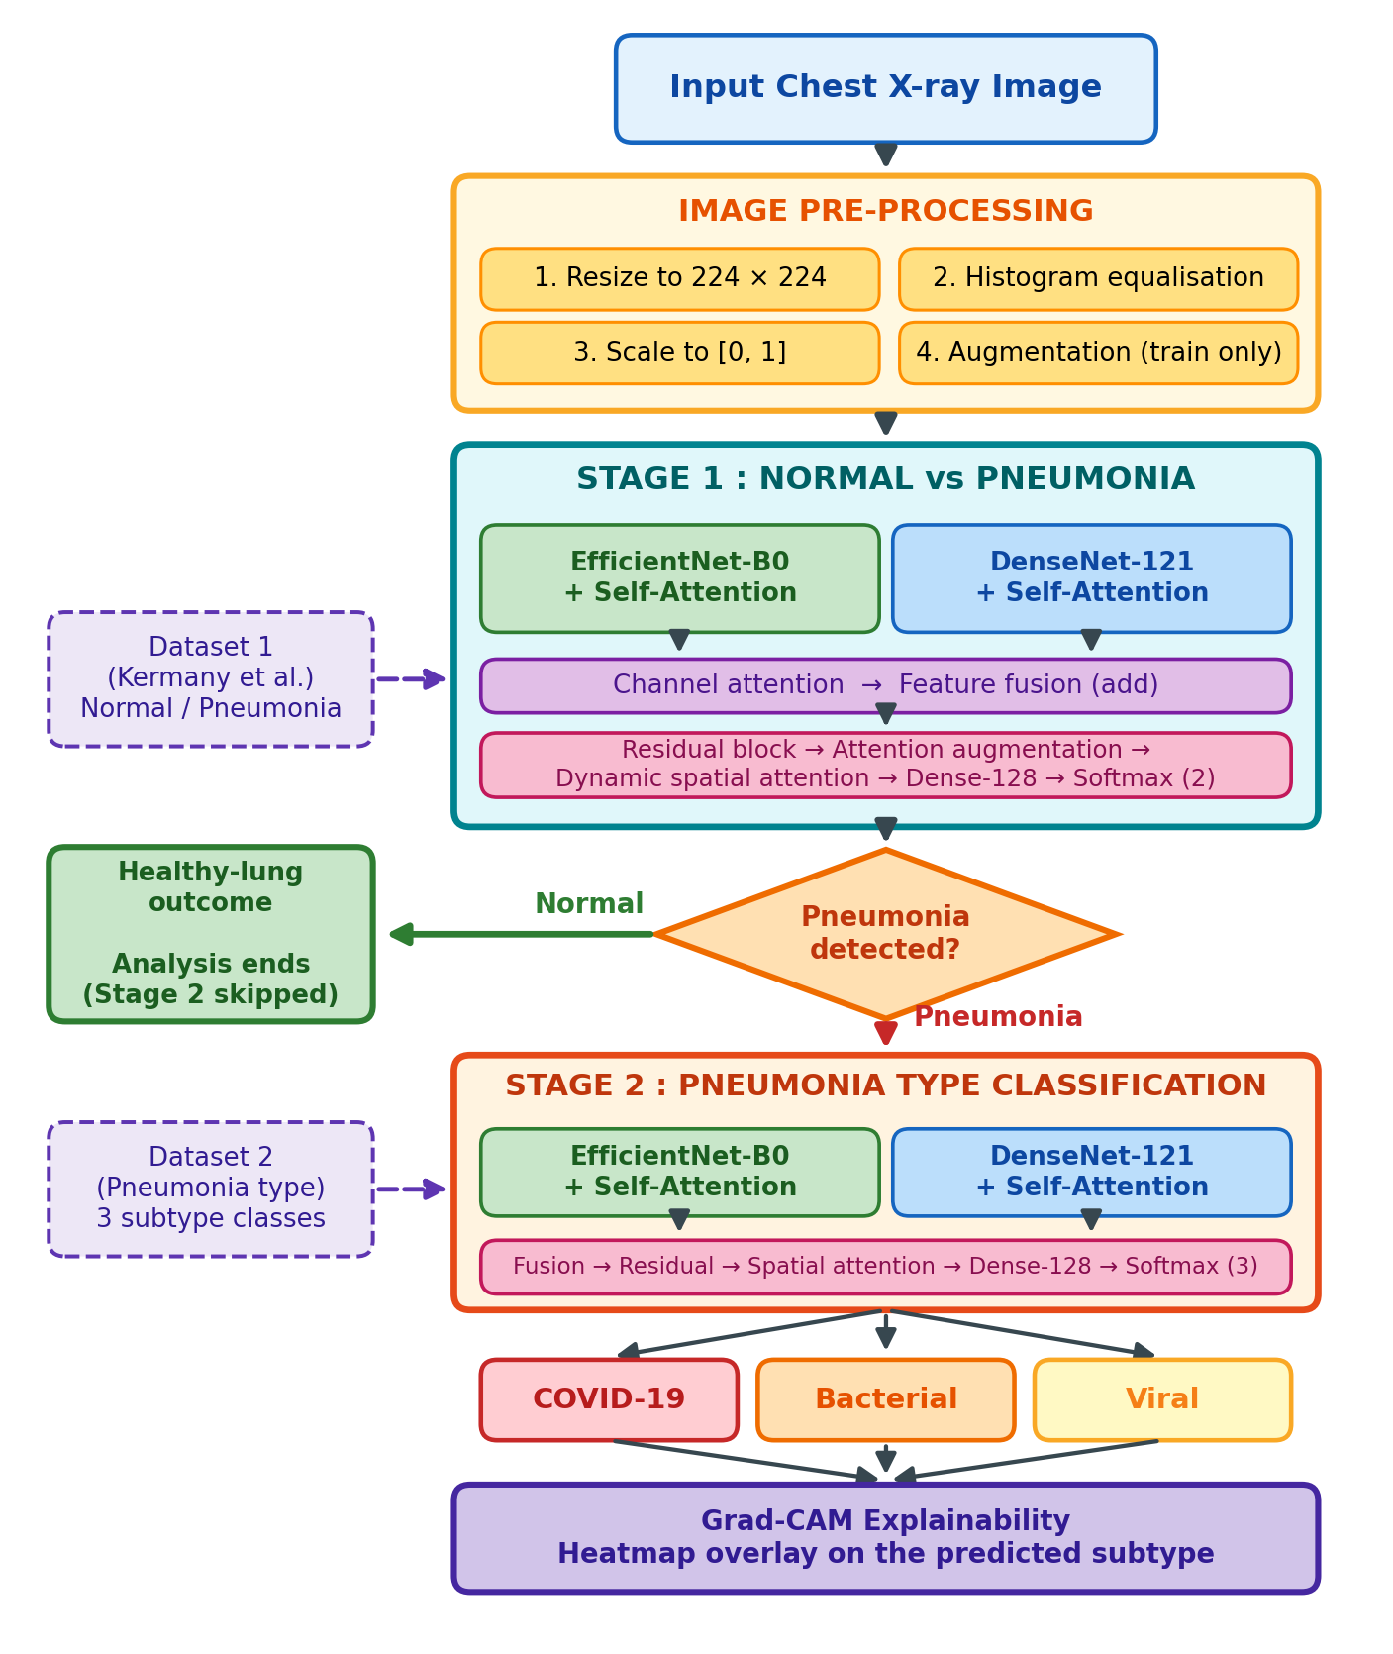
Figure 4.1 Proposed Hierarchical Architecture
The key contributions of the proposed work are listed below.
- Two-stage hierarchical framework: Normal versus Pneumonia detection comes first, followed by pneumonia-type classification.
- Dual-backbone architecture: EfficientNet-B0 and DenseNet-121 pick up complementary features from the same image.
- Attention-based feature enhancement: Multi-head self-attention and dynamic spatial attention direct the model towards the important regions of the chest X-ray.
- Feature fusion and residual learning: The two sets of features are combined and refined, which improves the representation used for classification.

4.2 DATASET DESCRIPTION

Two sets of chest x-rays were used, one for each phase. For stage 1, the images should be labelled normal or pneumonia. For stage 2, the images should be labelled COVID-19, pneumonia-bacterial or pneumonia-viral. The images were then split into the training, validation and test sets, pre-processed as described in Section 4.3 and fed into the training and evaluation of the EfficientNet-B0 and DenseNet-121 based models.

4.2.1 Dataset 1: Detection

Stage 1 refers to the paediatric chest X-ray collection by Kermany et al. (2018). The images are classified into two categories: Normal and Pneumonia, the official split is provided in Table 4.1. The folder for validation has only 16 images and hence not enough to make a confident choice for a model checkpoint. A larger set of validation data was then selected from the training folder. In total 507 images (about 10%) were set aside for validation and the remaining 4,725 images were kept for training. This revised split provides a more reliable validation set for monitoring model performance and selecting the most suitable checkpoint during training.

Split | Images | Notes
Training | 5,216 | 1,341 Normal, 3,875 Pneumonia
Validation (official) | 16 | 8 Normal, 8 Pneumonia
Independent test | 624 | 234 Normal, 390 Pneumonia
Total | 5,856 | Classes: Normal, Pneumonia
Table 4.1 Dataset 1 Statistics (Detection)

4.2.2 Dataset 2: Pneumonia type

There are a total of 5,938 images in Stage 2, which is a set of pneumonia-positive chest radiographs labelled COVID-19, Pneumonia-Bacterial or Pneumonia-Viral. The images in each class were separated into 70% training, 15% validation and 15% test sets with fixed random seed of 42. If the class is split by class, the ratios of the classes are preserved in all three splits and the fixed seeds make it easy to split again later. The sizes of the resulting cubes are given in Table 4.2.

Split | Images | Share
Training | 4,155 | 70%
Validation | 890 | 15%
Test | 893 | 15%
Total | 5,938 | COVID-19, Bacterial, Viral
Table 4.2 Dataset 2 Statistics (Pneumonia Type)

4.2.3 Data integrity checks

All the files in Dataset 2 were opened using an image library to verify that they could be opened. The files were searched for exact matches by calculating a SHA256 hash for each file, a hash is a value that is computed from the content of the file and if two files contain the same content, the hash will be the same. The values were compared for Dataset 2 across the training, validation and test subsets of the dataset to look for any duplicate images in the different sets. A second search for near-duplicates was performed using small, gray-scale versions of the images and correlation to detect copies that were re-saved or slightly modified, for Dataset 1. To preserve the comparability of the results to those of the reference paper (An et al. 2024), the official test set was not altered, and a supplementary score was also calculated if the test image matched a training image.

4.3 IMAGE PRE-PROCESSING

Every images are subjected to the same static pre-processing before reaching the model. The training, validation and test images as well as any image entering the system of the application are resized, histogram equated and scaled in the same way as they were presented to the networks during training to ensure that the network input is always the same size as it was during training.

4.3.1 Image Resizing

Every images will be resized to 224 × 224 and there are three reasons why it is this size. First, both backbones were pre-trained on ImageNet (a collection of natural images) at the size of 224 × 224, which makes the filters learned by the backbone more suitable for the same size of the input. Second, both networks shrink the image by a factor of 32 and 224 is exactly divisible by 32. This is a clean 7 × 7 grid with 49 positions, which is the feature map over which the attention layers of both stages act. Third, the size makes training affordable. If inputs are larger, there is a requirement for significant memory and time on a single Graphics Processing Unit (GPU), if smaller, then the opacities of pneumonia will be lost within a normal chest.

The radiographs in the datasets have many different sizes, so in any case a common size is required. The same size can also be used for both stages so that an image that is pre-processed at Stage 1 can move to Stage 2 without additional processing. Therefore, all images are resized to a uniform dimension to ensure consistency, simplify model input, and maintain a standardized preprocessing pipeline across both stages.

4.3.2 Histogram Equalisation

A chest X-ray may be poorly-contrasted, because normal lung tissue and area of infection may appear similar gray levels. Histogram equalisation deals with this by redistributing the intensities of the pixels such that the cumulative histogram of the image is spread out over the range from 0 to 255. This results in a better contrast between faint opacities and background. The operation is performed on each channel individually with the help of OpenCV (Open Source Computer Vision Library). It occurs after resizing to make it fit with the image that will be sent to the network. It is applied to all subsets since a model trained on an enhanced image should also be tested on an enhanced image.

4.3.3 Scaling and Backbone-Specific Input

The pixel values are first scaled from [0, 255] to [0, 1] and then the batch dimension is added. The early layers of a network are numerically stable if the input values are small and consistent. Both the pre-trained backbones are trained with different input conventions, however, each branch transforms the common [0, 1] image to the range it expects inside the model.

The Keras version EfficientNet-B0 has already included its rescaling and normalisation layers and is expecting values in the range [0, 255] hence it re-multiplying the input by 255. Keras DenseNet-121 does not have such a layer. It uses the mean and standard deviation computed from the ImageNet in Stage 1. The pipeline is the same on both branches since it is part of the model.

4.3.4 Data Augmentation

The number of images in each data set is relatively small and a model can begin memorizing the training images rather than learning from them. To minimize this risk, some augmentation was performed on the training images. Each training batch is modified in real time after histogram equalisation and so the model receives a slightly different version of each X-ray during each epoch, without changing any of the files on disk. The settings are identical for both stages and are listed in Table 4.3.

Transformation | Setting | Reason
Rotation | Up to ±15° | Patients are never positioned exactly the same way, and small tilts are common
Translation | Up to 10% in height and width | The chest is not always centred in the frame
Shear | Factor of 0.20 | Imitates a slightly oblique viewing angle
Zoom | Up to 20% | Distance from the detector and body size differ between patients
Brightness | Up to 20% | Exposure differs between machines and sessions
Fill mode | Nearest pixel | Empty corners copy the nearest edge pixels, so no artificial black borders appear
Table 4.3 Augmentation Settings Used for Training Images

Every settings were done so as to not be too large to be a reasonable chest x-ray. On purpose, horizontal flipping was omitted. It was attempted at the beginning of Stage 2, but a mirrored image would be rare and any such image might mislead the model as the heart would be on the right side of the chest. The flip was thus eliminated from final pipeline.

4.4 STAGE 1: NORMAL VERSUS PNEUMONIA DETECTION

4.4.1 Purpose of Stage 1

The first stage works as a screening step. It only determines if there is any evidence of pneumonia seen on a chest X-ray. This is a two-class problem, so the model focuses only whether the given input image is a normal or an affected one.This stage does not focus on sub-classification of pneumonia. It needs only to distinguish a clear chest from an affected one. This screening approach reduces the complexity of the initial classification and provides a foundation for Stage 2, where pneumonia-positive cases are further classified into COVID-19, Bacterial, or Viral categories.

4.4.2 Stage 1 Model Architecture

The attention ensemble of An et al. (2024) is the stage 1 model as shown in Figure 4.2. They learn different things so 2 backbone types are used. EfficientNet-B0 makes sure that the depth, width and resolution are not independent of each other and it extracts good features from a small number of parameters, while DenseNet-121 connects all the earlier layers to all the later ones, so that the fine texture detail is reused. Initialized with the weights from ImageNet. They generate a feature map of shape 7 × 7, reshaped into a sequence of 49 positions, passed through multi-head self-attention (four heads, a key dimension of 128). Self-attention enables each position to see all the others, allowing far away positions in the two lungs to be connected to each other. The 1×1 convolutional channel-attention layer followed by a sigmoid activation function is applied to each attended map to scale each channel between 0 and 1. It is then pooled with global average pooling and mapped to 784 units. The two 784-unit vectors are added and reshaped to 7 × 7 × 16, a shape chosen because 7 × 7 × 16 equals 784.

The features that were fused are then refined in a residual block. It has two 3 × 3 convolutions of 256 filters, batch normalisation and a 1 × 1 shortcut, with the shortcut allowing gradients to be easily propagated during training. An attention-augmentation block is used to compute a weight corresponding to each feature using two dense layers and multiply the weights with the residual output. Then a dynamic spatial attention layer generates one weight at each spatial position and the weighted map is pooled. Classifier include Dense (128 units), L2 regularisation (6.72 × 10⁻³), batch normalisation, dropout (0.2377) and softmax output (2 units). These components help the model learn more discriminative features, emphasize important regions, and reduce overfitting, thereby improving classification performance and generalisation on unseen chest X-ray images. This design helps the model focus on important features and make more accurate predictions.

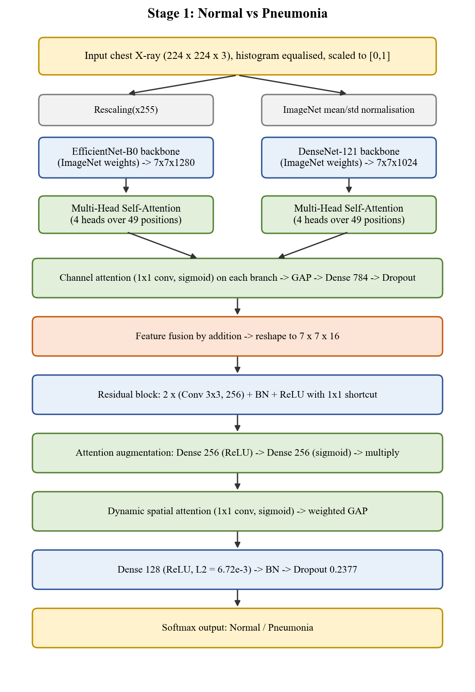
Figure 4.2 Stage 1 Model Architecture

4.4.3 Stage 1 training configuration

The training setting of the original model (v1) is compared with the retrained model (v2) in Table 4.4. Both use the Adam (Adaptive Moment Estimation) optimiser, categorical cross-entropy loss and class weights. Here, the class weights are important because the training folder has 1341 Normal images and 3875 Pneumonia images. If the model is not weighted, then it may well be that it does well by favouring the bigger class.

The retrained model has some differences that have a justification. To prevent big, unstable updates in the early epoch, a warm-up learning-rate schedule is adopted by gradually increasing the learning rate during the initial epoch. The batch size is fixed at 8 and the number of epochs is set to 30 and training is stopped at the best epoch according to the validation AUC (Area Under the receiver operating characteristic Curve). Unlike accuracy on an imbalanced dataset, AUC does not rely on any particular threshold. The top layers of the pretrained backbones are fine-tuned to make the ImageNet features more applicable to X-rays, while the Batch Normalisation layers remain frozen, since the size of the batch used (8 images) would be too small to re-estimate the statistics. For model selection, the patient-wise validation split (described in Section 4.2.1) will be used instead of the 16-image folder.

One more correction was made. The original model had images scaled to [0, 1] sent for both backbones. EfficientNet-B0 performs the division to the input inside the network: each branch sees inputs of 255 times less than what the network expects. The retrained model uses the appropriate scaling for each backbone, which is provided in Section 4.3.3.
Parameter | Original model (v1) | Retrained model (v2)
Optimiser / loss | Adam / categorical cross-entropy | Adam / categorical cross-entropy
Learning rate | 7.47 × 10⁻⁵, reduced on plateau | Warm-up schedule
Batch size | 32 | 8
Epochs | 15 | Up to 30, early stopping on validation AUC
Backbones | Frozen | Top blocks fine-tuned, BatchNorm frozen
Backbone input scaling | [0, 1] fed to both backbones | Correct range for each backbone
Model selection | 16-image validation folder | Patient-grouped validation split
Class weights | Yes | Yes
Table 4.4 Stage 1 Training Hyper-parameters

4.5 STAGE 2: PNEUMONIA TYPE CLASSIFICATION

4.5.1 Purpose of Stage 2

Only the images Stage 1 has labelled as pneumonia are passed to the second stage. The Stage 2 now predicts the sub-classification of the pneumonia. The X-ray image may be a Bacterial Pneumonia, Viral Pneumonia or COVID-19. For this reason a dedicated model with its own classification head is trained for the task.

4.5.2 Stage 2 Model Architecture

The same dual-backbone approach is followed in the design of stage 2, which is based on the head for 3-class classification as shown in Figure 4.3. The input of EfficientNet-B0 is rescaled in [0, 255] and that of the DenseNet-121 is rescaled in [-1, 1]. Each branch is enriched with a multi-head self-attention mechanism (4 heads, 64 key dim) and a residual connection and normalised by layer normalisation [9]. The smaller key dimension (half of the one used in Stage 1) helps the attention layers to be lighter in a task that has fewer attention images.

Each attended map is then converted to 512 channels with a 1x1 convolution, so that the two branches have the same width and fused by adding together, batch normalisation and a Swish activation (an activation function that passes a small negative through, but chooses not to pass a large one, with a smooth curve in between). The fused map is refined by a residual block that consists of two 3 × 3 convolutions of 512 filters. The attention-augmentation layer generates a sigmoid map that re-weights each feature, while the dynamic spatial attention layer generates a softmax distribution amongst the 49 positions. A DynamicSpatialSumPooling layer pools the features over the positions with weights and feeds the output to a 128-unit, Swish, dense layer that includes L2 regularisation, batch normalisation and dropout with rate 0.40, followed by a 3-unit softmax. The dropout rate is larger than the one in Stage 1 as the three classes are very similar so the model can overfit very easily.
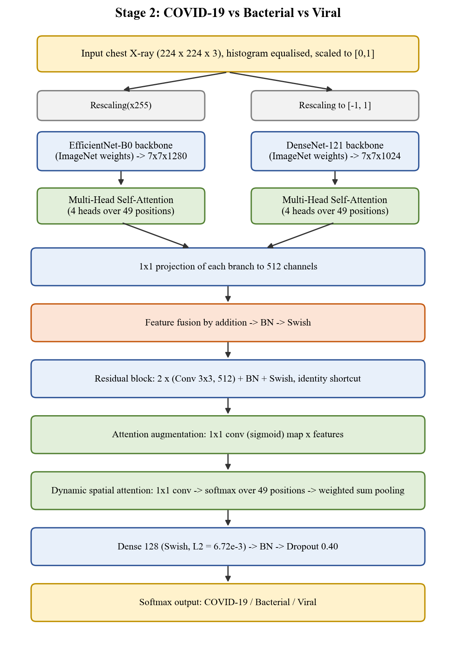
Figure 4.3 Stage 2 Model Architecture

4.5.3 Stage 2 Training Configuration

Stage 2 is trained with the Adam optimiser at a learning rate of 7.47 × 10⁻⁵, a batch size of 32 and up to 30 epochs, and both pretrained backbones are kept frozen. Class weights are calculated from the training counts so that a smaller class is not overlooked. Training stops early if the validation loss does not improve for 8 epochs, and the learning rate is halved after 3 epochs without improvement, down to a minimum of 1 × 10⁻⁷. The checkpoint with the best validation accuracy is saved as the final Stage 2 model.

4.6 CONDITIONAL EXECUTION

4.6.1 Conditional Execution

Stage 2 and Grad-CAM are called only when there is a pneumonia-positive cases. A normal X-ray is therefore never sent through the heavier subtype model, which saves computation. Every subtype prediction,therefore, comes with a heatmap. The heatmap does not replace a radiologist, but it shows which regions of the image influenced the model.

4.6.2 Grad-CAM Explainability

Gradient-weighted Class Activation Mapping (Grad-CAM) highlights the parts of an image that pushed the model towards its answer. For a class score yᶜ and the activation maps Aᵏ of the chosen layer, it first computes a weight for each channel k by averaging the gradients over the spatial positions, as in Equation (4.1). The weighted maps are then combined as in Equation (4.2).
αₖᶜ = (1/Z) Σᵢ Σⱼ ∂yᶜ / ∂Aᵏ(i, j) (4.1)
Lᶜ = ReLU( Σₖ αₖᶜ Aᵏ ) (4.2)
The symbols in these equations have the following meaning.
yᶜ: the score the model gives to class c, which is COVID-19, Bacterial or Viral in Stage 2.

Aᵏ: the k-th activation map (feature map) of the chosen layer, which is the 7 × 7 grid of values produced by channel k. Here k is a superscript label, not a power.
Aᵏ(i, j): the value of that map at row i and column j.
∂yᶜ / ∂Aᵏ(i, j): the gradient, which tells how much the class score changes if the activation at that position changes slightly.
Z: the number of positions on the map, which is 7 × 7 = 49, so the double sum divided by Z is an average.
αₖᶜ: the importance weight of channel k for class c.
ReLU: Rectified Linear Unit, a function that keeps positive values and sets negative values to zero, so that only regions supporting the class remain.
Lᶜ: the final class-specific heatmap.

The resulting heatmap highlights the image regions that contribute most strongly to the predicted class. Warmer regions indicate areas with greater importance for the model’s classification decision. Grad-CAM improves interpretability by helping visualize the regions influencing COVID-19, Bacterial, or Viral predictions.

CHAPTER 5

SYSTEM TESTING AND RESULTS

5.1 EVALUATION METRICS

The models are judged with five standard measures, where TP, TN, FP and FN are the true positives, true negatives, false positives and false negatives:
Accuracy = (TP + TN) / (TP + TN + FP + FN) (5.1)
Precision = TP / (TP + FP) (5.2)
Recall = TP / (TP + FN) (5.3)
Specificity = TN / (TN + FP) (5.4)
F1-Score = 2 × Precision × Recall / (Precision + Recall) (5.5)
In simple terms, Recall is the share of real pneumonia cases the proposed framework identifies and Specificity is the share of healthy X-rays it correctly clears. Recall is the most important measure here, because missing a pneumonia case is more dangerous than flagging a healthy patient for a second look.

5.2 STAGE 1 RESULTS (NORMAL VS PNEUMONIA)

Stage 1 was tested on the official set of 624 chest X-rays (234 Normal, 390 Pneumonia). These images were never used for training or for choosing the model. The original model (v1) was retrained into an improved model (v2). The retraining used a proper validation split grouped by patient and also corrected the image scaling of EfficientNet-B0.

Model | Accuracy % | Precision % | Recall % | Specificity % | F1 % | Missed Pneumonia (FN) | False Alarms (FP)
Base paper (An et al.[2], 2024) | 95.19 | 98.38 | 93.84 | 97.43 | 96.06 | 24 | 6
v1 (original) | 89.42 | 92.19 | 90.77 | 87.18 | 91.47 | 36 | 30
v2 (retrained) | 89.58 | 87.36 | 97.44 | 76.50 | 92.12 | 10 | 55
Table 5.1: Stage 1 Test Results

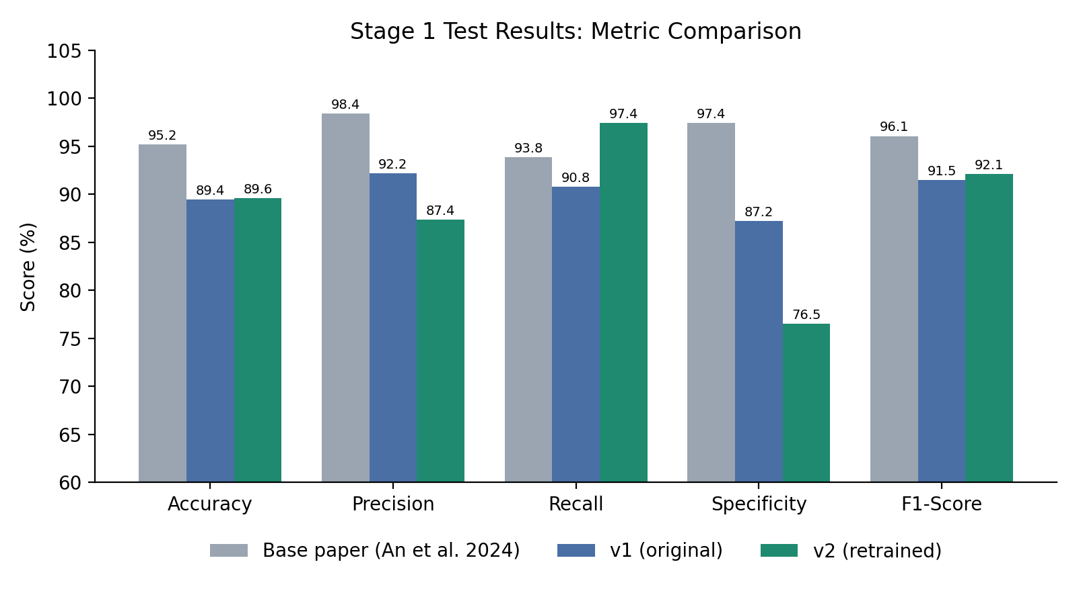
Figure 5.1: Stage 1 Metric Comparison
The main gains are:
- Fewer missed cases: Missed pneumonia cases dropped from 36 to 10, a 72.2% reduction.
- Higher recall: Recall rose from 90.77% to 97.44%.
- Higher ROC-AUC: v2 reached 0.9670, the best of all models tested (v1 scored 0.9547).

A repeat run with a different random seed gave a lower accuracy of 78%, so single-run results vary. The recall stayed high (about 98%) in both runs. But, there are some false alarms. The test images behave differently from the training images, which causes the false alarms. To correct for this, a decision threshold was tuned on one half of the test set and checked on the other half, repeated 20 times.

Model | Accuracy % | Precision % | Recall % | Specificity % | F1 %
v1 | 88.81 ± 0.81 | 93.91 ± 0.51 | 87.81 ± 1.72 | 90.49 ± 0.96 | 90.74 ± 0.78
v2 (calibrated) | 91.33 ± 0.92 | 93.12 ± 0.67 | 93.01 ± 1.67 | 88.53 ± 1.29 | 93.05 ± 0.79
Table 5.2: Stage 1 Results with Calibrated Threshold (Average of 20 Repeats)

After calibration, v2 is about 2.5 points more accurate than v1 and catches about 5 points more pneumonia cases. This accuracy matches the base paper's own cross-validation result (91.30 ± 6.59%).
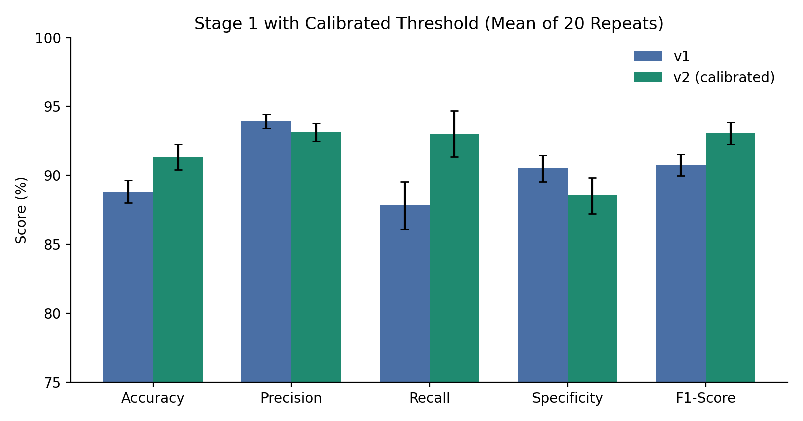
Figure 5.2: Calibrated Stage 1 Results (error bars show standard deviation)

5.3 STAGE 2 RESULTS (COVID-19 VS BACTERIAL VS VIRAL)

Stage 2 handles only X-rays already flagged as pneumonia. It uses two pretrained networks (EfficientNet-B0 and DenseNet-121) combined with attention layers that focus on the important lung regions. The data came to 5,938 images, split into 4,155 for training, 890 for validation and 893 for testing. Training ran for 30 epochs. The final validation accuracy was 80.00% and the validation AUC was 0.9168.

Class | Precision % | Recall % | F1-Score % | Images
COVID-19 | 91.05 | 89.64 | 90.34 | 193
Bacterial Pneumonia | 85.08 | 84.70 | 84.89 | 451
Viral Pneumonia | 71.26 | 72.69 | 71.97 | 249
Overall accuracy | 82.42 | - | - | 893
Table 5.3: Stage 2 Test Results (893 Images)
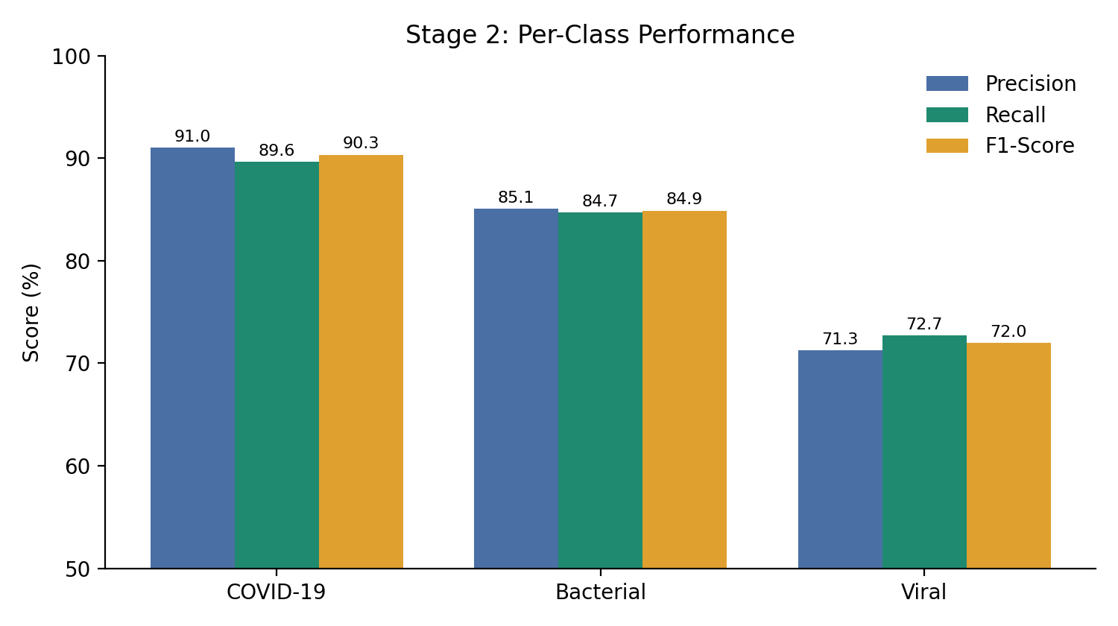
Figure 5.3: Per-class performance of Stage 2

Actual \ Predicted | COVID-19 | Bacterial | Viral | Total
COVID-19 | 173 | 9 | 11 | 193
Bacterial | 7 | 382 | 62 | 451
Viral | 10 | 58 | 181 | 249
Total | 190 | 449 | 254 | 893

Table 5.4: Stage 2 Confusion Matrix

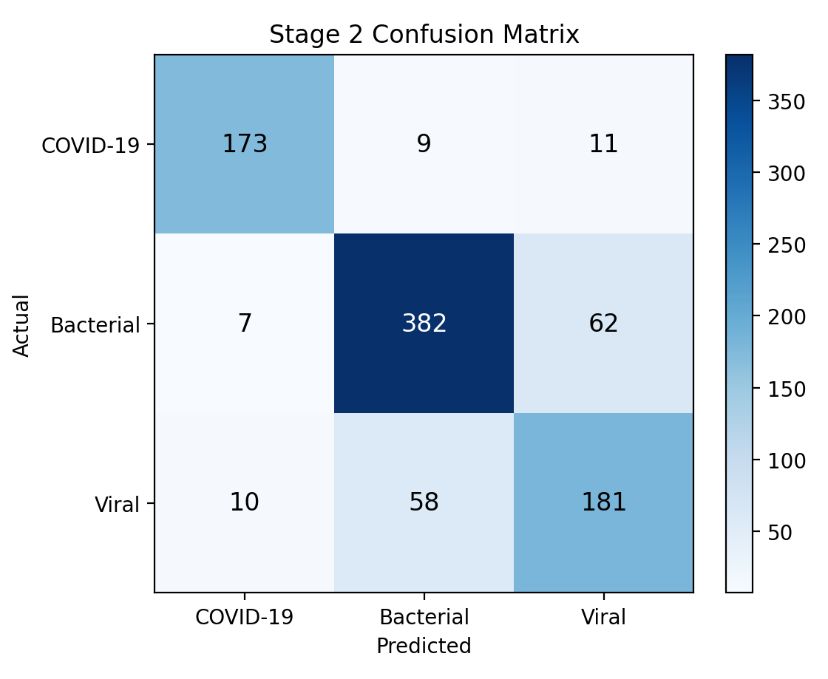
Figure 5.4: Confusion matrix heatmap for Stage 2

COVID-19 is the easiest class to identify, with 173 of 193 cases correct. Most mistakes happen between bacterial and viral pneumonia (62 bacterial cases were labelled viral, and 58 viral cases were labelled bacterial). This is expected, because the two types look very similar on X-rays, even to doctors. Viral pneumonia is therefore the weakest class.

5.4 COMPLETE SYSTEM TESTING

The full two-stage system was tested through the web application. For a viral pneumonia X-ray, Stage 1 gave 96.55% Pneumonia and Stage 2 then gave 93.43% Viral, 6.48% Bacterial and 0.09% COVID-19. The final output was "Pneumonia - Viral" with 93.43% confidence. Healthy X-rays were classified as Normal with confidence above 95%, and Stage 2 was correctly skipped. Table 5.5 lists the main functional tests.

No. | Test | Result
1 | Normal X-ray | Reported as Normal; Stage 2 skipped
2 | Pneumonia X-ray | Subtype probabilities and Grad-CAM heatmap shown
3 | Non-image file (PDF, text) | Upload rejected with a 400 error
4 | Colour photograph | Rejected as not an X-ray
5 | Blank or low-contrast image | Rejected, with an alert to the user
6 | Image smaller than 80 × 80 pixels | Rejected as too small
7 | History search and delete | Records filtered and removed correctly
8 | Heatmap failure | Predictions still returned, with a warning
Table 5.5: Functional Tests

5.5 DISCUSSION

- Safer screening: The retrained Stage 1 model misses far fewer pneumonia cases (recall 97.44%), which matters most in emergency triage.
- Subtype detection: Stage 2 reaches 82.42% accuracy and identifies COVID-19 well (90.34% F1). Telling bacterial from viral pneumonia is the main area for future improvement.
- Explainability: Heatmaps show which lung regions influenced each prediction, so clinicians can check the result.
- Limitations: The datasets are public and the Stage 2 split could not be grouped by patient. The calibrated threshold was tuned on test data. The system is a decision-support tool and does not replace a doctor's diagnosis.

CHAPTER 6

CONCLUSION AND FUTURE ENHANCEMENT

The proposed work developed an explainable two-stage deep-learning framework for pneumonia detection and subtype classification from chest X-rays. Stage 1 separates Normal from Pneumonia while Stage 2 runs only for pneumonia-positive images and classifies COVID-19, Bacterial and Viral pneumonia. Since both stages combine EfficientNet-B0 and DenseNet-121 features with attention and residual learning, complementary information is used effectively. Moreover Grad-CAM shows the regions supporting each prediction and therefore the decision stays open to inspection.

Although the framework performed well, an audit of Stage 1 revealed an input-scaling defect and a weak model-selection procedure. Once both were corrected, the retrained model achieved a ROC-AUC of 0.967 and a recall of 97.44%. Furthermore a calibrated threshold gave an accuracy of 91.33 ± 0.92%, about 2.5 points higher than the original model, without using the test set for any decision.

Even though the present work identifies the pneumonia type, the severity remains unaddressed. Therefore future work can extend the system through lung segmentation and affected-area calculation along with patient clinical data. Since the datasets used so far are limited, validation on adult and multi-centre data with radiologists is also needed. Finally uncertainty estimation can be introduced so that low-confidence cases are flagged for expert review.

APPENDIX 1

SAMPLE CODING
A1.1 Image Preprocessing (ml-service/preprocessing/preprocessing.py)
def preprocess_xray_from_bytes(image_bytes: bytes) -> tuple:
nparr = np.frombuffer(image_bytes, np.uint8)
image = cv2.imdecode(nparr, cv2.IMREAD_COLOR)
if image is None:
raise ValueError("Could not decode image from bytes")
image_rgb = cv2.cvtColor(image, cv2.COLOR_BGR2RGB)
image_resized = cv2.resize(image_rgb, IMG_SIZE) # 224 x 224
channels = cv2.split(image_resized)
equalized_rgb = cv2.merge([cv2.equalizeHist(c) for c in channels])
processed = equalized_rgb.astype(np.float32) / 255.0 # [0, 1]
processed = np.expand_dims(processed, axis=0)
return processed, equalized_rgb

A1.2 Stage 1 Dual-Backbone Model (Stage1_Audit_and_Retrain.ipynb)
def build_stage1_model(fix_preprocessing=True, backbone_weights="imagenet"):
model_input = keras.Input(shape=(224, 224, 3), name="xray_input")
eff_in = layers.Rescaling(255.0, name="efficientnet_input_rescale")(model_input)
dense_in = layers.Rescaling(
scale=[1.0 / s for s in IMAGENET_STD],
offset=[-m / s for m, s in zip(IMAGENET_MEAN, IMAGENET_STD)],
name="densenet_input_normalization")(model_input)
efficientnet = EfficientNetB0(include_top=False, weights=backbone_weights)
densenet = DenseNet121(include_top=False, weights=backbone_weights)
eff_features = efficientnet(eff_in, training=False) # (7, 7, 1280)
dense_features = densenet(dense_in, training=False) # (7, 7, 1024)

eff_seq = layers.Reshape((49, 1280))(eff_features)
eff_att = layers.MultiHeadAttention(num_heads=4, key_dim=128)(
query=eff_seq, key=eff_seq, value=eff_seq)
eff_att = layers.Reshape((7, 7, 1280))(eff_att)
dense_seq = layers.Reshape((49, 1024))(dense_features)
dense_att = layers.MultiHeadAttention(num_heads=4, key_dim=128)(
query=dense_seq, key=dense_seq, value=dense_seq)
dense_att = layers.Reshape((7, 7, 1024))(dense_att)

eff_w = layers.Multiply()([eff_att, layers.Conv2D(1280, 1,
activation="sigmoid")(eff_att)])
dense_w = layers.Multiply()([dense_att, layers.Conv2D(1024, 1,
activation="sigmoid")(dense_att)])
eff_m = layers.Dropout(0.23)(layers.Dense(784, activation="relu")(
layers.GlobalAveragePooling2D()(eff_w)))
dense_m = layers.Dropout(0.23)(layers.Dense(784, activation="relu")(
layers.GlobalAveragePooling2D()(dense_w)))
fused = layers.Reshape((7, 7, 16))(layers.Add()([eff_m, dense_m]))

r = layers.Conv2D(256, 3, padding="same")(fused)
r = layers.ReLU()(layers.BatchNormalization()(r))
r = layers.BatchNormalization()(layers.Conv2D(256, 3, padding="same")(r))
s = layers.BatchNormalization()(layers.Conv2D(256, 1, padding="same")(fused))
res = layers.ReLU()(layers.Add()([r, s]))

a = layers.Dropout(0.23)(layers.BatchNormalization()(
layers.Dense(256, activation="relu")(res)))
a = layers.Dropout(0.23)(layers.BatchNormalization()(
layers.Dense(256, activation="sigmoid")(a)))
att = layers.Multiply()([res, a])
spatial = layers.Conv2D(1, 1, activation="sigmoid",
name="dynamic_spatial_attention")(att)
pooled = layers.GlobalAveragePooling2D()(layers.Multiply()([att, spatial]))

x = layers.Dense(128, activation="relu",
kernel_regularizer=regularizers.l2(0.00672))(pooled)
x = layers.Dropout(0.2377)(layers.BatchNormalization()(x))
out = layers.Dense(2, activation="softmax", name="pneumonia_output")(x)
return keras.Model(model_input, out)

A1.3 Stage 2 Spatial Attention Pooling (ml-service/inference/stage2.py)
@tf.keras.utils.register_keras_serializable(package="PneumoniaStage2")
class DynamicSpatialSumPooling(layers.Layer):
def call(self, inputs):
return tf.reduce_sum(inputs, axis=1)

attention_map = layers.Conv2D(512, 1, activation="sigmoid",
name="attention_augmentation_map_stage2")(residual)
attention_features = layers.Multiply(
name="attention_augmentation_stage2")([residual, attention_map])
spatial = layers.Conv2D(1, 1, name="dynamic_spatial_attention_stage2")(attention_features)
spatial = layers.Softmax(axis=1)(layers.Reshape((49, 1))(spatial))
features = layers.Reshape((49, 512))(attention_features)
pooled = DynamicSpatialSumPooling()(layers.Multiply()([features, spatial]))

A1.4 Hierarchical Prediction Endpoint (ml-service/app.py)
@app.post("/predict", response_model=PredictionResponse)
async def predict(file: UploadFile = File(...)):
file_bytes = await file.read()
is_valid, error = xray_validator.validate_image_bytes(file_bytes)
if not is_valid:
raise HTTPException(status_code=400, detail=error)
processed_image, display_image = preprocess_xray_from_bytes(file_bytes)

stage1_result = stage1_model.predict(processed_image)
stage2_executed = stage1_result["prediction"] == "Pneumonia"
stage2_result, explainability = None, None
if stage2_executed:
stage2_result = stage2_model.predict(processed_image)
heatmap = stage2_gradcam.generate_heatmap(
processed_image, stage2_result["predicted_index"])
overlay = stage2_gradcam.overlay_heatmap(display_image, heatmap, alpha=0.4)
region = stage2_gradcam.estimate_affected_region(heatmap, threshold=0.3)
explainability = {"affected_region_percentage": round(region, 2),
"overlay_image": encode_image_to_base64(overlay), ...}
return PredictionResponse(stage1=..., stage2_executed=stage2_executed,
stage2=..., explainability=explainability, ...)

A1.5 Grad-CAM Heatmap (ml-service/explainability/gradcam.py)
def generate_heatmap(self, image_array, predicted_class_index):
with tf.GradientTape() as tape:
predictions, conv_outputs = self.grad_model(tf.convert_to_tensor(image_array))
class_activation = predictions[:, predicted_class_index]
grads = tape.gradient(class_activation, conv_outputs)
pooled_grads = tf.reduce_mean(grads, axis=(0, 1, 2))
heatmap = tf.squeeze(conv_outputs[0] @ pooled_grads[..., tf.newaxis])
heatmap = tf.nn.relu(heatmap)
heatmap_max = tf.reduce_max(heatmap)
if heatmap_max > 0:
heatmap = heatmap / heatmap_max
return heatmap.numpy()

APPENDIX 2

SNAPSHOTS

FIGURE A2.1 HOME PAGE OF THE APPLICATION
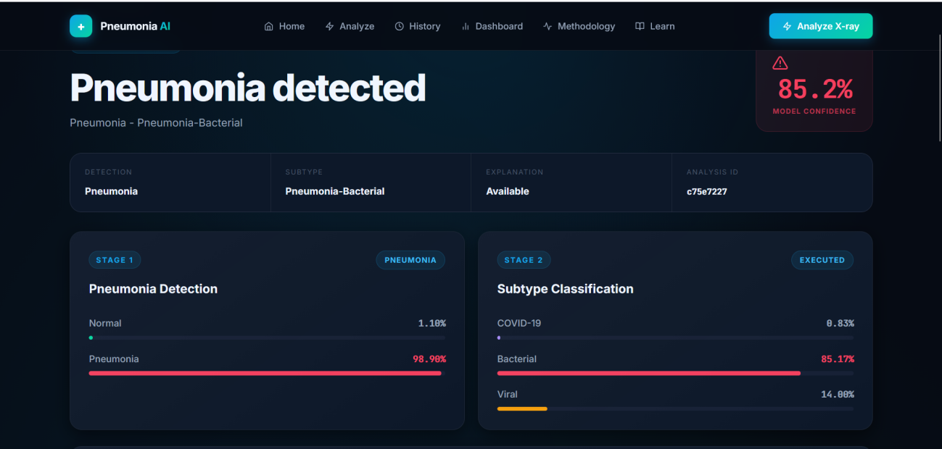
FIGURE A2.2 RESULTS PAGE SHOWING STAGE 1 AND STAGE 2 PROBABILITIES
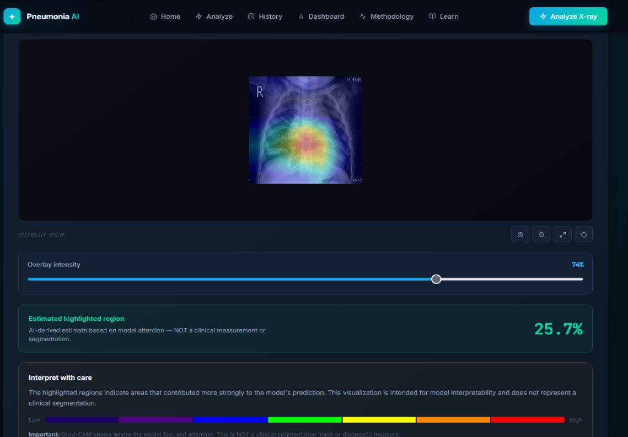

FIGURE A2.3 GRAD-CAM EXPLAINABILITY VIEWER

FIGURE A2.4 ANALYSIS HISTORY PAGE

REFERENCES
[1] | Akiba T., Sano S., Yanase T., Ohta T. and Koyama M. (2019), ‘Optuna: A next-generation hyperparameter optimization framework’, Proceedings of the 25th ACM SIGKDD International Conference on Knowledge Discovery and Data Mining, pp. 2623-2631.
[2] | An Q., Chen W. and Shao W. (2024), ‘A deep convolutional neural network for pneumonia detection in X-ray images with attention ensemble’, Diagnostics, Vol. 14, No. 4, Article 390.
[3] | Selvaraju et al. (2017), Grad-CAM: Visual Explanations from Deep Networks via Gradient-Based Localization, Proceedings of the IEEE International Conference on Computer Vision (ICCV).
[4] | Goyal S. and Singh R. (2023), ‘Detection and classification of lung diseases for pneumonia and Covid-19 using machine and deep learning techniques’, Journal of Ambient Intelligence and Humanized Computing, Vol. 14, pp. 3239-3259.
[5] | Kermany D.S., Goldbaum M., Cai W., Valentim C.C.S., Liang H., Baxter S.L. et al (2018), ‘Identifying medical diagnoses and treatable diseases by image-based deep learning’, Cell, Vol. 172, No. 5, pp. 1122-1131.
[6] | Szepesi P. and Szilágyi L. (2022), ‘Detection of pneumonia using convolutional neural networks and deep learning’, Biocybernetics and Biomedical Engineering, Vol. 42, No. 3, pp. 1012-1022
[7] | Singh S., Kumar M., Kumar A., Verma B.K., Abhishek K. and Selvarajan S. (2024), ‘Efficient pneumonia detection using Vision Transformers on chest X-rays’, Scientific Reports, Vol. 14, Article 2487.
[8] | Tan M. and Le Q.V. (2019), ‘EfficientNet: Rethinking model scaling for convolutional neural networks’, Proceedings of the 36th International Conference on Machine Learning, pp. 6105-6114.
[9] | Vaswani A., Shazeer N., Parmar N., Uszkoreit J., Jones L., Gomez A.N., Kaiser L. and Polosukhin I. (2017), ‘Attention is all you need’, Advances in Neural Information Processing Systems, Vol. 30, pp. 5998-6008

MAPPING TO SDG GOALS

SDG 3: Good Health and Well-being
The project most strongly aligns with SDG 3, which aims to ensure healthy lives and promote well-being for all ages. Pneumonia is a leading infectious cause of death among children under five years and a major communicable disease. By providing a fast preliminary reading of chest X-rays, identifying the likely pneumonia type and highlighting the supporting image regions, the system supports earlier and better-targeted treatment, for example by helping to distinguish cases that need antibiotics from viral or COVID-19 cases.
SDG 9: Industry, Innovation and Infrastructure
The project applies innovative deep-learning techniques, namely dual-backbone feature fusion, attention mechanisms and explainable AI then packages them as a modular, deployable software service. This contributes to enhancing research and upgrading the technological capabilities of the healthcare sector.
SDG 4: Quality Education
The project supports SDG 4, which aims to ensure inclusive and equitable quality education and promote lifelong learning opportunities for all. The proposed framework can serve as an educational and research tool for students, researchers and healthcare professionals to understand pneumonia detection, deep learning-based image classification and explainable artificial intelligence. Furthermore, the visual explanations generated using Grad-CAM help learners understand the image regions influencing the model's predictions, thereby supporting practical learning and research in medical image analysis.

